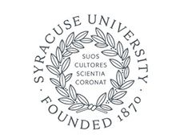

Wednesday, November 13, 2019
Dear Students, Faculty and Staff,
Just a few hours ago, I returned from Washington, D.C., where I was speaking with students, faculty and alumni at an event co-sponsored by The Lender Center for Social Justice. I went from the airport to the Barnes Center at The Arch to briefly visit with our students who gathered there in an effort to effect change on issues that are important to our community.
I received from the students a list of short- and long-term recommendations. They are thoughtful and constructive, and our university will be responding. I’ve also received communications from students, faculty and staff. I have asked members of the Student Experience team, including Rob Hradsky, vice president of the student experience, and Marianne Thomson, dean of students, and other staff members, to work closely with our student leaders, student organizations and students from across campus on these issues. Even before that work proceeds, I have requested some immediate actions:
• I have asked that there be prompt implementation of a new protocol for how the University responds to bias incidents. It is vital that we simultaneously prioritize caring for students directly impacted, communicating in a timely manner to the campus community, and swiftly investigating the incident. Chief Diversity and Inclusion Officer Keith Alford, Department of Public Safety (DPS) Chief Bobby Maldonado and Dean Thomson will finalize this approach by next week.
• Many students have raised questions about the current Code of Student Conduct and whether it needs to be revisited and revised, especially as it pertains to bias-related incidents. I have directed Dean Thomson to work with student leaders on this and promptly report any suggested changes.
I remain deeply concerned about what happened at Day Hall and the campus climate issues I have been discussing with students.
Sincerely,
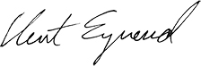
Chancellor Kent Syverud

